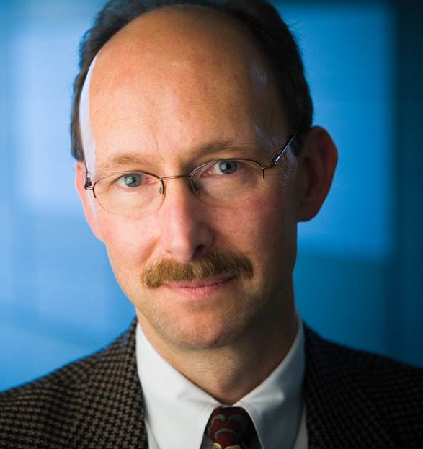

Andrew J. Gellman

Lord Professor of Chemical Engineering,
Chemistry and Materials Science
Co-Director – Scott Institute for Energy Innovation

Carnegie Mellon University

Professor Gellman received a B.Sc. in chemistry from the California Institute of Technology in 1981 and a Ph.D. in chemistry from the University of California at Berkeley in 1985. After spending one year as a postdoctoral researcher at Cambridge University in England he started his academic career as an Assistant Professor of Chemistry at the University of Illinois. He joined the faculty of Chemical Engineering at Carnegie Mellon in 1992 and is now Lord Professor of Chemical Engineering, Chemistry, and Materials Science. During the year 2000 he was the Zeneca Senior Fellow in the Department of Chemical Engineering at Cambridge University in the U.K. and then a visiting professor in the Department of Materials at the ETH-Zurich in Switzerland. He served as the Department Head of Chemical Engineering at Carnegie Mellon from January 2003 to November 2013. In February 2008 he was named the first Consortium Director of the NETL Regional University Alliance (NETL-RUA, 2008-2014), a consortium formed by Carnegie Mellon University and regional universities to work with the DOE National Energy Technology Lab. In September 2012 he was named co-Director of the Scott Institute for Energy Innovation at Carnegie Mellon.
Professor Gellman’s independent research is in the area of surface chemistry with particular emphasis on catalytic surface chemistry, enantioselective chemistry on chiral surfaces, tribology and high throughput study of alloy surfaces. He has developed a number of experiments and experimental methodologies for exploring fundamental aspects of surface chemistry in each of these areas. The most recent focus of his research group has been the study of enantioselectivity on naturally chiral metal surfaces. His research is now turning towards the development and application of high throughput methods for study of alloy surface properties such as catalysis. Professor Gellman has won a number of national and international awards for his research including: Fellow of the American Chemical Society (2011) and of the AVS (2012), Welch Foundation Lectureship (Texas - 2001), the Zeneca Fellowship (University of Cambridge - 2000), the Ipatieff Prize (American Chemical Society - 1998), Alfred P. Sloan Research Fellowship (A.P. Sloan Foundation 1991-93), Packard Fellowship in Science and Engineering (David and Lucile Packard Foundation - 1989-94), and the Distinguished New Faculty in Chemistry Award (Camille and Henry Dreyfus Foundation - 1986).

